ABES ENGINEERING COLLEGE, GHAZIABAD

DEPARTMENT OF ELECTRONICS
& COMMUNICATION ENGINEERING



COURSE MATERIAL
Subject Name: Emerging Domain in Electronics Engineering
Subject Code: BEC-101/201T
Branch/Semester: All Branches / 1st or 2nd
Session: 2022-23 (Odd & Even-Semester)
Faculty: Mr. Mudit Saxena; Ms. Arpita Johri, Mr. Shahbaz Alam, Dr. Shivam Singh & Ms. Shobha Sharma

EVALUATION - SCHEME, B.Tech- I YR./ I SEM (AKTU)



EVALUATION - SCHEME, B.Tech- I YR./ II SEM (AKTU)



UNIT-1 (Special Purpose Two Terminal Devices)

Contents as per syllabus:

- Light Emitting Diodes (LEDs)
  - Introduction to LEDs
  - Need to Study LEDs
  - Constructional Details of LEDs
  - Working Principle of LEDs
  - VI Characteristics of LEDs
  - Types of LEDs
  - Advantages & Disadvantages of LEDs
  - Applications of LEDs
  - Few Circuits implemented in industries

- Photodiodes
  - Introduction to Photodiodes
  - Need to Study Photodiodes
  - Constructional Details of Photodiodes
  - Working Principle of Photodiodes
  - VI Characteristics of Photodiodes
  - Types of Photodiodes
  - Advantages & Disadvantages of Photodiodes
  - Applications of Photodiodes
  - Few Circuits implemented in industries

- Varactor Diodes
3.1. Introduction to Varactor Diodes
3.2. Need to Study Varactor Diodes
3.3. Constructional Details of Varactor Diodes
3.4. Working Principle of Varactor Diodes
3.5. VI Characteristics of Varactor Diodes
3.6. Advantages & Disadvantages of Varactor Diodes
3.7. Applications of Varactor Diodes
3.8. Few Circuits implemented in industries

- Tunnel Diodes
4.1. Introduction to Tunnel Diodes
4.2. Need to Study Tunnel Diodes
4.3. Constructional Details of Tunnel Diodes
4.4. Working Principle of Tunnel Diodes
4.5. VI Characteristics of Tunnel Diodes
4.6. Advantages & Disadvantages of Tunnel Diodes
4.7. Applications of Tunnel Diodes
4.8. Few Circuits implemented in industries

- Liquid Crystal Displays (LCDs)
5.1. Introduction to LCDs
5.2. Need to Study LCDs
5.3. Constructional Details of LCDs
5.4. Working Principle of LCDs
5.5. Advantages & Disadvantages of LCDs
5.6. Applications of LCDs
5.7. Few Circuits implemented in industries

- Light Emitting Diodes (LEDs)
  - Introduction to LEDs
- A light-emitting diode (LED) is a semiconductor device that emits light when an electric current flows through it.
- Light-emitting diodes are heavily doped p-n junctions.
- Based on the semiconductor material used and the amount of doping, an LED will emit a colored light at a particular spectral wavelength when forward biased.
- An LED is encapsulated with a transparent cover so that emitted light can come out.
- The difference between the LED Symbol and a typical p-n junction diode is that the LED Symbol has an arrow pointing away from the diode, indicating that the diode is emitting light.

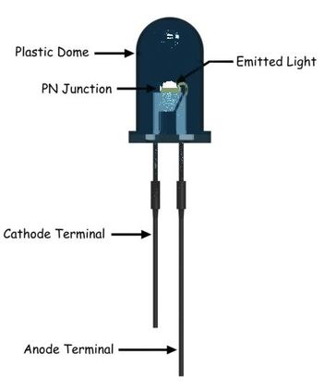

Fig. 1.1.1. Structure of LED

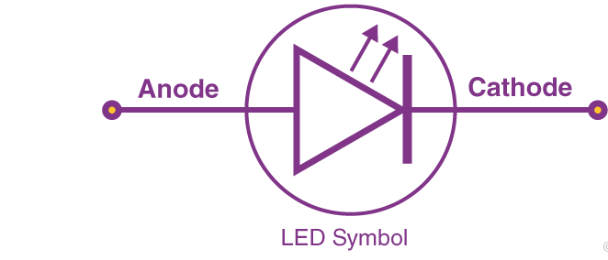

Fig. 1.1.2. Symbol of LED

  - Need to Study LEDs
The light-emitting diode (LED) is today's most energy-efficient and rapidly-developing lighting technology.

  - Constructional Details of LEDs
The three semiconductor layers deposited on the substrate are n-type semiconductor, p-type semiconductor and active region. Active region is present in between the n-type and p-type semiconductor layers. When LED is forward biased, free electrons from n-type semiconductor and holes from p-type semiconductor are pushed towards the active region.
When free electrons from n-side and holes from p-side recombine with the opposite charge carriers (free electrons with holes or holes with free electrons) in active region, an invisible or visible light is emitted.
In LED, most of the charge carriers recombine at active region. Therefore, most of the light is emitted by the active region. The active region is also called as depletion region.
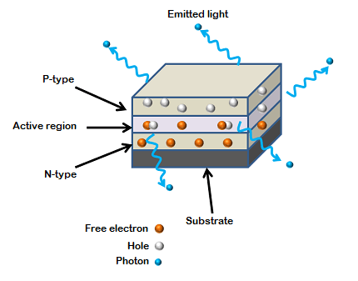

Fig. 1.3.1. Construction of LED

  - Working Principle of LEDs
- LED (Light Emitting Diode) is an optoelectronic device which works on the principle of electro-luminance.
- Light Emitting Diode (LED) works only in forward bias condition.
- Electro-luminance is the property of the material to convert electrical energy into light energy and later it radiates this light energy.
- Light energy is generated when an electron from a higher energy band falls into the low energy band and releases energy.
- In other words, when charge carriers electrons and hole combines, they release light energy.
- The electrons are majority carriers in N-type and holes are majority carriers in P-type. The electrons of N-type are in the conduction band and holes of P-type are in the valence band.
- The energy level of the conduction band is higher than the energy level of the Valence band. Thus, if electrons tend to recombine with holes, they have to lose some part of the energy to fall in lower energy band.
- The electrons can lose their energy either in the form of heat or light.
- The electrons in Silicon and Germanium lose their energy in the form of heat. Thus, they are not used for LEDs as we want semiconductor in which electrons lose their energy in the form of light. Thus, semiconductor compounds such as Gallium Phosphide (Gap), Gallium Arsenide (GaAs), Gallium Arsenide Phosphide (GaAsP) etc. emit light when electrons-holes recombine. The electrons in these compounds lose their energy by emission of photons.
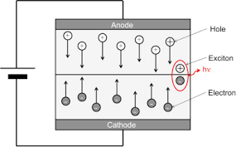
Fig. 1.4.1. Working Principle of LED

  - VI Characteristics of LEDs
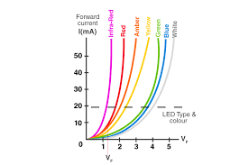
Fig. 1.5.1. VI Characteristics of LED

The V-I characteristic is nonlinear as seen above. The flow of current is less until the forward voltage is reached above which the current increases exponentially with increase in voltage. The colour of the LED is determined by the bandgap of semiconductor and forward voltage. As current grows in the forward bias, the intensity of light increases until it hits a maximum, and further increases in current decrease the intensity of light.

  - Types of LEDs
∗ Gallium Arsenide (GaAs) – infra-red
∗ Gallium Arsenide Phosphide (GaAsP) – red to infra-red, orange
∗ Aluminium Gallium Arsenide Phosphide (AlGaAsP) – high-brightness red, orange-red, orange, and yellow
∗ Gallium Phosphide (GaP) – red, yellow and green
∗ Aluminium Gallium Phosphide (AlGaP) – green
∗ Gallium Nitride (GaN) – green, emerald green
∗ Gallium Indium Nitride (GaInN) – near ultraviolet, bluish-green and blue
∗ Silicon Carbide (SiC) – blue as a substrate
∗ Zinc Selenide (ZnSe) – blue
∗ Aluminium Gallium Nitride (AlGaN) – ultraviolet

  - Advantages & Disadvantages of LEDs
Advantages:
- Temperature Range: It can be operated over a wide range of temperature ranging from 0⁰C -70⁰C.
- Switching Time: The Switching time of LEDs is in order of 1ns. Thus, they are useful in dynamic operations where a large number of arrays are used.
- Low Power Consumption: They consume less power and they can be used even if the dc power supplied is low.
- Better Controlling: The radiant power of LEDs is the function of the current flowing in it. Thus, the light intensity of LED can be controlled easily.
- Economical and Reliable: LEDs are cheap and they possess a high degree of reliability.
- Small Size and Portability: They are small in size and can be stacked together for the formation of alphanumeric displays.
- Higher Efficiency: The efficiency of LEDs to convert power to light energy is 10-50 times greater than that of the tungsten lamp.
Disadvantages:
- Overvoltage or Overcurrent: The LEDs may get damaged when the current is
increased beyond a certain limit.
- Overheating due to radiant power: It gets overheated with an excessive
increase in radiant power. This may lead to damage of LED.

  - Applications of LEDs
LEDs find applications in various fields, including optical communication, alarm and security systems, remote-controlled operations, robotics, etc. It finds usage in many areas because of its long-lasting capability, low power requirements, swift response time, and fast switching capabilities.
- LED is used as a bulb in the homes and industries
- The light emitting diodes are used in the motorcycles and cars
- These are used in the mobile phones to display the message

- At the traffic light signals

  - Few Circuits implemented in industries
Many electrical types of equipment employ visible LEDs as indicator lamps, automobiles use them as rear-window and brake lights, and billboards and signs use them as alphanumeric displays or even full-colour posters. Infrared LEDs are used in autofocus cameras and television remote controls, as well as in fibre-optic telecommunication systems as light sources.

- Indicator in AC circuit: It can be used as an indicator in AC circuit, but the internal resistance of LED is quite small. Thus, a resistor in series is connected with LED so that the overcurrent can flow through the resistor and can protect LED from getting damaged.
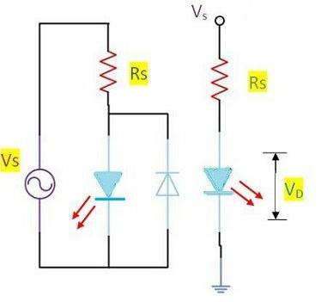
Fig. 1.9.1. LED as an Indicator in AC

- Display Panel Indicator: LEDs are used for displaying information processed by electronics circuits. The display format of LED is shown in below diagram.
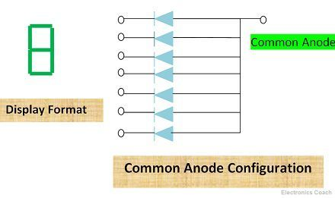
Fig. 1.9.1. LED Display

- Digital Watches, Calculators & Multimeters: The LEDs which emit visible light are used in digital watches and Calculators for indication purpose.
- Remote Control Systems & Burglar alarm Systems: Those LEDs which emit invisible infrared light such as GaAs LEDs are used in such applications.
- Source in Optical Communication System: It is also used in optical fibre communication system.

- Photodiodes
  - Introduction to Photodiodes
The purpose of a photodiode is to generate current that is proportional to the intensity of visible, infrared, or ultraviolet light. The technical term for light intensity as measured by a photodiode is illuminance.
A photodiode has transparent packaging that allows light to reach the pn junction, and in a properly designed photodiode circuit, incident light will create precise variations in the amount of current flowing through the photodiode.

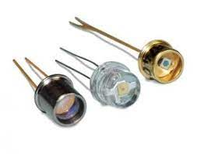
Fig. 2.1.1. Photodiodes

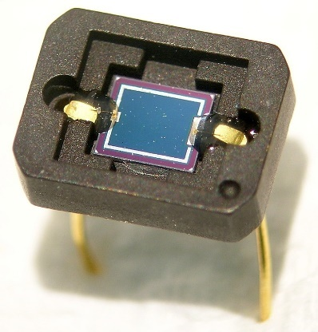

Fig. 2.1.2. Close up of a Photodiode

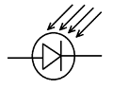
Fig. 2.1.2. Symbol of Photodiode

  - Need to Study Photodiodes
Photodiodes are frequently used photodetectors, which have largely replaced the formerly used vacuum phototubes. They are semiconductor devices which contain a p–n junction, and often an intrinsic (undoped) layer between n and p layers. Devices with an intrinsic layer are called p–i–n or PIN photodiodes. Light absorbed in the depletion region or the intrinsic region generates electron–hole pairs, most of which contribute to a photocurrent. The photocurrent can be quite precisely proportional to the absorbed (or incident) light intensity over a wide range of optical powers.

  - Constructional Details of Photodiodes

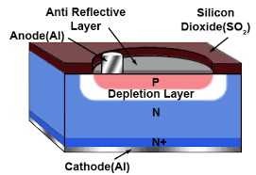

Fig. 2.3.1. Construction of Photodiode

- The surface of a layer of N type is bombarded with P type silicon ions to produce a P type layer about 1 µm thick.
- During the formation of the diode, electrons from the N type layer are attracted into the P type material and holes from the P type are attracted into the N type layer, resulting in the removal of free charge carriers close to the PN junction, so creating a depletion layer.
- The (light facing) top of the diode is protected by a layer of Silicon Dioxide (SO₂) in which there is a window for light to shine on the semiconductor.
- This window is coated with a thin anti-reflective layer of Silicon Nitride (SiN) to allow maximum absorption of light and an anode connection of aluminium (Al) is provided to the P type layer.
- Beneath the N type layer is a more heavily doped N+ layer to provide a low resistance connection to the cathode.

  - Working Principle of Photodiodes
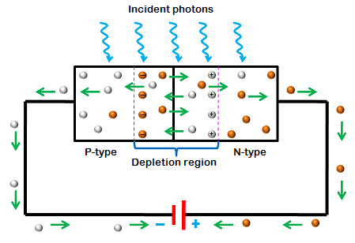
Fig. 2.4.1. Working Principle of Photodiode

- The working principle of a photodiode is, when a photon of ample energy strikes the diode, it makes a couple of an electron-hole. This mechanism is also called the inner photoelectric effect.
- If the absorption arises in the depletion region junction, then the carriers are removed from the junction by the inbuilt electric field of the depletion region.
- Therefore, holes in the region move toward the anode, and electrons move toward the cathode, and a photocurrent will be generated. The entire current through the diode is the sum of the absence of light and the photocurrent. So, the absent current must be reduced to maximize the sensitivity of the device.

Modes of Operation
The operating modes of the photodiode include three modes, namely Photovoltaic mode, Photoconductive mode, an avalanche diode mode
Photovoltaic Mode: This mode is also known as zero-bias mode, in which a voltage is produced by the lightened photodiode. It gives a very small dynamic range & non-linear necessity of the voltage formed.
Photoconductive Mode: The photodiode used in this photoconductive mode is more usually reverse biased. The reverse voltage application will increase the depletion layer’s width, which in turn decreases the response time & the junction capacitance. This mode is too fast and displays electronic noise
Avalanche Diode Mode: Avalanche diodes operate in a high reverse bias condition, which permits the multiplication of an avalanche breakdown to each photo-produced electron-hole pair. This outcome is an internal gain in the photodiode, which slowly increases the device response.

Why is Photodiode Operated in Reverse Bias?
The photodiode operates in the mode of photoconductive. When the diode is connected in reverse bias, then the depletion layer width can be increased. So, this will diminish the capacitance of the junction & the response time. In fact, this biasing will cause quicker response times for the diode. So, the relation between photocurrent & illuminance is linearly proportional.

  - VI Characteristics of Photodiodes
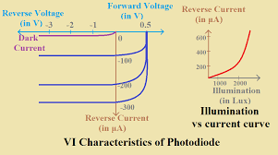

Fig. 2.5.1. Working Principle of Photodiode
The value of reverse current is independent of reverse voltage. It depends on the intensity of the illumination of light. The variation of current w.r.t variation of illumination is shown above. The reverse current is almost zero when the illumination of light is zero. This minimum reverse current is known as Dark Current.

  - Types of Photodiodes
Although there are numerous types of photodiode available in the market and they all work on the same basic principles, though some are improved by other effects. The working of different types of photodiodes works in a slightly different way, but the basic operation of these diodes remains the same. The types of photodiodes can be classified based on their construction and functions as follows.
- PN Photodiode
- Schottky Photo Diode
- PIN Photodiode
- Avalanche Photodiode

  - Advantages & Disadvantages of Photodiodes

Advantages
- Less resistance
- Quick and high operation speed
- Long life span.
- Fastest photodetector.
- Spectral response is good.
- Doesn’t use high voltage.
- Frequency response is good.
- Solid and low-weight.
- It is extremely responsive to the light.
- Dark current is less.
- High quantum efficiency.
- Less noise.

Disadvantages
- Temperature stability is poor.
- Change within current is extremely little, therefore may not be enough to drive the circuit.
- The active area is small.
- Usual PN junction photodiode includes a high response time.
- It has less sensitivity.
- It mainly works by depending on the temperature.
- It uses offset voltage.

  - Applications of Photodiodes
- Are used as switching devices in switching circuits.
- Light detectors, light-operated switches.
- Also used in electronic control circuits like counting devices and communication systems.
- Are used as encoders, demodulators.

- Are used in computer card punching and tapes

  - Few Circuits implemented in industries

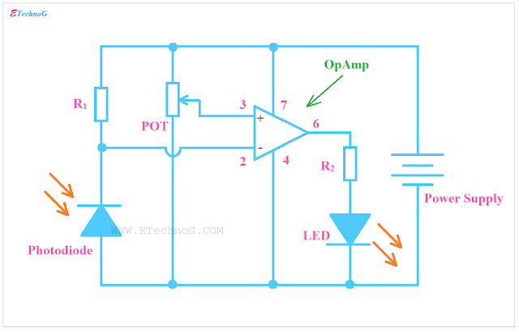
Fig. 2.9.1. Light Level Indicator Circuit

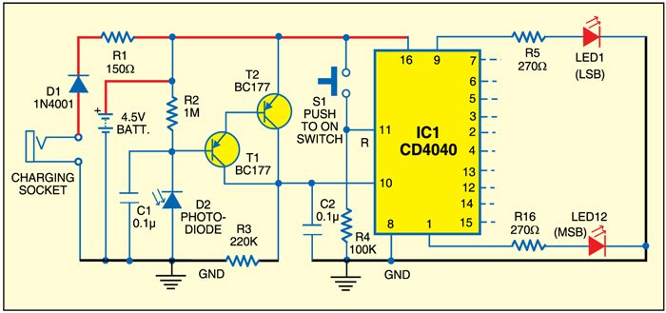
Fig. 2.9.2. Photo Counter gadget to detect whether somebody opened a cupboard or drawer in the absence.

- Varactor Diodes
3.1. Introduction to Varactor Diodes
- The varactor diode is also known as variable capacitance diode, variable reactance diode or tuning diode.
- The varactor diode always function in reverse biasing condition.
- Its doping level is high to increases capacitance of its depletion region, here the capacitance term is used because its operation is similar to the capacitor.

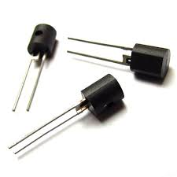
Fig. 3.1.1. Varactor Diodes

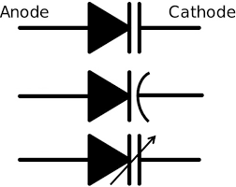

Fig. 3.1.1. Symbol of Varactor Diodes

3.2. Need to Study Varactor Diodes
Varactor or varicap diodes are used mainly in radio frequency or RF circuit designs to provide voltage controlled variable capacitance.
These electronic components can be used in a whole variety of ways where a capacitance level needs to be controlled by a voltage, and without them, many of the capabilities we enjoy in radios, mobile phones and many other devices would not be possible.
3.3. Constructional Details of Varactor Diodes
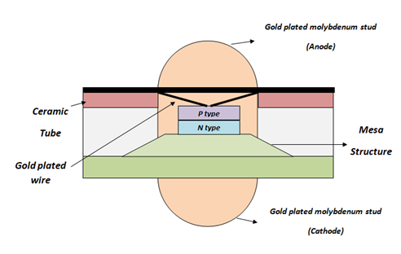

Fig. 3.3.1. Construction of Varactor Diodes

It consists of P type and N type semiconductor material which is made up of Silicon or Gallium arsenide depending upon the application. Silicon is used for low frequency applications and Gallium arsenide is used for high frequency applications.
These P type and N type material is placed on the Mesa table like structure. In the other type of diodes both the materials are uniformly doped but in varactor diode near the PN junction the concentration of impurity is less and gradually increases at the other side of the layer. The entire structure is covered by ceramic except some portion of Molybdenum stud.

3.4. Working Principle of Varactor Diodes
- It is formed of P-type and N-type semiconductor and reverse biasing is applied to it.
- Varactor diode produces capacitance effect, this is because it cathode and anode terminals acts as the plate of the capacitor and region between them acts as dielectric medium
- The majority carriers in an N-type semiconductor are electrons and the majority carriers in a P-type semiconductor are holes. At the junction, the electrons and holes recombine.
- Due to which immobile ions accumulate at the junction. And no more current can flow due to majority carriers. Thus, the depletion region is formed.
- The depletion region is called so because it is depleted of charge carriers i.e. the majority carriers are absent in depletion region. This works as a dielectric layer and P and N-type semiconductor works as plates of a capacitor.
- When the reverse bias is applied to P-N junction, the width of depletion layer increases. And with the increase of reverse voltage gradually the depletion layer increases even more. Thus, the depletion region creates Transition capacitance C_{T.}
C_{T} = ɛA/W
Here, C_{T} is Transition capacitance, ɛ is dielectric constant, A is the area of plates of the capacitor and W is the width of the depletion layer.
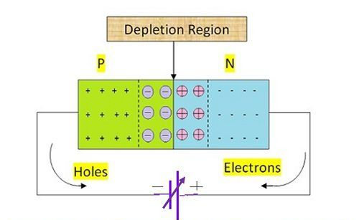
Fig. 3.4.1. Working Principle of Varactor Diodes

- It is evident from the above relation that transition capacitance is inversely proportional to width of the depletion layer. Thus, if we want the high magnitude of capacitance the width should be small. And the width will be small if we will apply low reverse voltage.
- Similarly, if we require low capacitance the width should be large and to increase the width the reverse voltage applied should be high. Thus, this width can be controlled with applied reverse voltage.
- The tuning range of the capacitor varies with the doping level of the diode. For abrupt doping junction the doping will be uniform, but for the hyper abrupt junction, the doping profile will be non-uniform.
3.5. VI Characteristics of Varactor Diodes

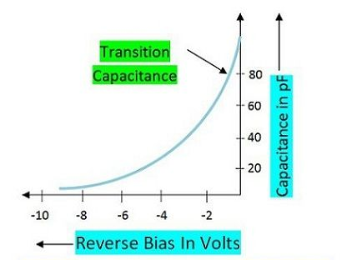

Fig. 3.5.1. Characteristics of Varactor Diodes

3.6. Advantages & Disadvantages of Varactor Diodes

Advantages
- Low Noise: It generates less noise as compared to the other P-N junction diode. Thus, the power loss due to noise is low in varactor diodes.
- Portability: It is portable due to the small size and lightweight.
- Reliability: It is more reliable than other P-N junction diodes.
- Economical: It is a low-cost diode thus, it is economical to use in various applications.

Disadvantages
These are specially designed to work in the reverse biased mode, it possesses the least significance when operated in forward biasing.
3.7. Applications of Varactor Diodes
- Television receivers: Varactor diodes are used as tuned capacitors and have replaced mechanically tuned capacitors in various applications. It is used in television in the resonant tank circuit.
- Radio receivers: Radio receivers also use this diode for tuning purposes.
- Frequency Multiplier: It is also used as a frequency multiplier in various electronic circuits.
- Phase Locked Loops: It is used in Phase locked loop for frequency modulation. Varactor diodes help in achieving frequency modulation. Thus, in communication devices varactor diodes are significant.
- Voltage controlled oscillators: Voltage control oscillators are used extensively in transmission and receiving circuits in communication. And varactor diode plays a significant role in construction of voltage-controlled oscillator.
- Parametric Amplifiers: It is used in parametric amplifier as a significant component.

3.8. Few Circuits implemented in industries

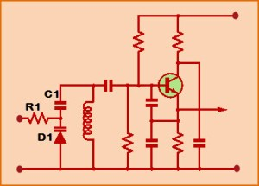
Fig. 3.8.1. Varactor Diodes in Voltage Controlled Oscillators

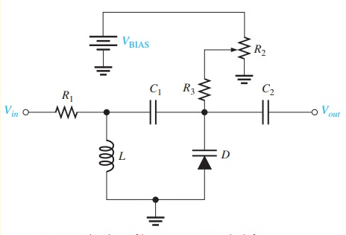
Fig. 3.8.2. Varactor Diodes in Tuning Circuits

- Tunnel Diodes
4.1. Introduction to Tunnel Diodes
- The tunnel diode is a highly conductive, heavily doped PN-junction diode in which the current induces because of the tunnelling. The tunnelling is the phenomenon of conduction in the semiconductor material in which the charge carrier punches the barrier instead of climbing through it.
- A tunnel diode was discovered by Leo Esaki in the year 1958. He noticed that if a semiconductor diode is doped heavily through impurities, then it will generate negative resistance that means the flow of current across the diode will decreases once the voltage enhances. This is referred to as “Tunneling”.

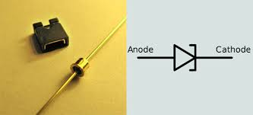

Fig. 4.1.1. Tunnel Diode and its symbol

4.2. Need to Study Tunnel Diodes
Very high frequency applications using the tunnel diode are possible because the tunneling action occurs so rapidly that there is no transit time effect and therefore no signal distortion. Tunnel diodes are also used extensively in high-speed switching circuits because of the speed of the tunneling action.

4.3. Constructional Details of Tunnel Diodes
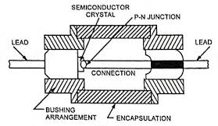

Fig. 4.3.1. Construction of Tunnel Diode

- Tunnel Diode are usually fabricated from germanium, gallium arsenide or gallium antimonide.
- Silicon is not used in the tunnel diode construction, because the ratio of peak value of forward current to the value of valley current (i.e., I_{P}/I_{V}) is maximum in case of gallium arsenide (approximately 20) and comparatively smaller for germanium (roughly 10) but very small in case of silicon (about 3).
- The source materials are highly doped semiconductor crystals with an impurity
concentration of the order of 10²⁵ per cubic metre or more.

4.4. Working Principle of Tunnel Diodes
- The depletion region is a region in a p-n junction diode where mobile charge carriers (free electrons and holes) are absent.
- Depletion region acts like a barrier that opposes the flow of electrons from the n-type semiconductor and holes from the p-type semiconductor.
- The width of a depletion region depends on the number of impurities added. Impurities are the atoms introduced into the p-type and n-type semiconductor to increase electrical conductivity.
- If a small number of impurities are added to the p-n junction diode (p-type and n-type semiconductor), a wide depletion region is formed. On the other hand, if large number of impurities are added to the p-n junction diode, a narrow depletion region is formed.
- In tunnel diode, the p-type and n-type semiconductor is heavily doped which means a large number of impurities are introduced into the p-type and n-type semiconductor. This heavy doping process produces an extremely narrow depletion region. The concentration of impurities in tunnel diode is 1000 times greater than the normal p-n junction diode.
When a forward bias voltage is applied to the ordinary p-n junction diode,
- The width of depletion region decreases and at the same time the barrier height also decreases. However, the electrons in the n-type semiconductor cannot penetrate through the depletion layer because the built-in voltage of depletion layer opposes the flow of electrons.
- If the applied voltage is greater than the built-in voltage of depletion layer, the electrons from n-side overcomes the opposing force from depletion layer and then enters into p-side. In simple words, the electrons can pass over the barrier (depletion layer) if the energy of the electrons is greater than the barrier height or barrier potential. Therefore, an ordinary p-n junction diode produces electric current only if the applied voltage is greater than the built-in voltage of the depletion region.
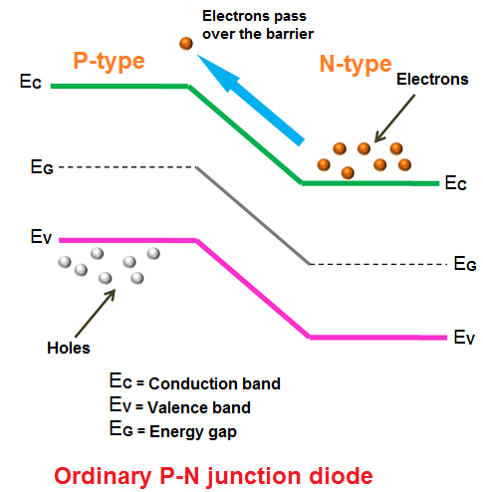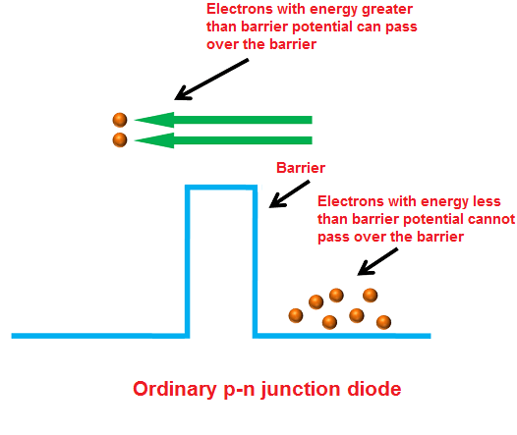

Fig. 4.4.1. Current in normal PN junction Diode

Tunneling

- In tunnel diode, the valence band and conduction band energy levels in the n-type semiconductor are lower than the valence band and conduction band energy levels in the p-type semiconductor.
- Unlike the ordinary p-n junction diode, the difference in energy levels is very high in tunnel diode. Because of this high difference in energy levels, the conduction band of the n-type material overlaps with the valence band of the p-type material.
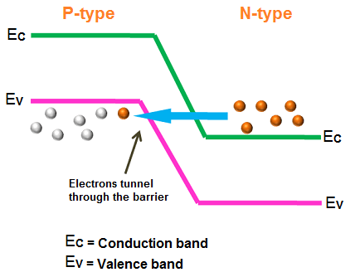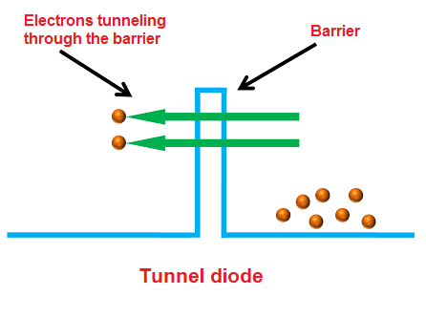

Fig. 4.4.2. Tunneling

- Quantum mechanics says that the electrons will directly penetrate through the depletion layer or barrier if the depletion width is very small. The depletion layer of tunnel diode is very small (nm). So, the electrons can directly tunnel across the small depletion region from n-side conduction band into the p-side valence band.
- In tunnel diodes, the electrons need not overcome the opposing force from the depletion layer to produce electric current. The electrons can directly tunnel from the conduction band of n-region into the valence band of p-region. Thus, electric current is produced in tunnel diode.

In an Unbiased tunnel diode
- When no voltage is applied to the tunnel diode, it is said to be an unbiased tunnel diode. In tunnel diode, the conduction band of the n-type material overlaps with the valence band of the p-type material because of the heavy doping.
- Because of this overlapping, the conduction band electrons at n-side and valence band holes at p-side are nearly at the same energy level. So, when the temperature increases, some electrons tunnel from the conduction band of n-region to the valence band of p-region.
- In a similar way, holes tunnel from the valence band of p-region to the conduction band of n-region.
- However, the net current flow will be zero because an equal number of charge carriers (free electrons and holes) flow in opposite directions.

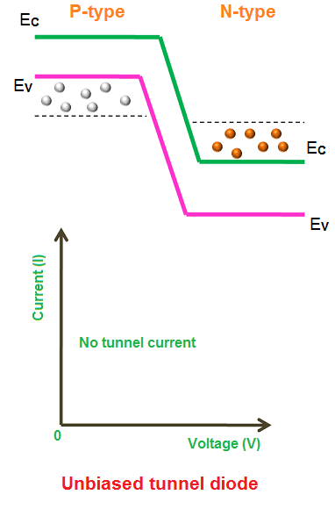
Fig. 4.4.3. Unbiased Tunnel Diode

In a biased tunnel diode – Forward Voltage is increased
- When a small voltage is applied to the tunnel diode which is less than the built-in voltage of the depletion layer, no forward current flows through the junction.
- However, a small number of electrons in the conduction band of the n-region will tunnel to the empty states of the valence band in p-region.
- This will create a small forward bias tunnel current. Thus, tunnel current starts flowing with a small application of voltage.
- When the voltage applied to the tunnel diode is slightly increased, a large number of free electrons at n-side and holes at p-side are generated. Because of the increase in voltage, the overlapping of the conduction band and valence band is increased.
- In simple words, the energy level of an n-side conduction band becomes exactly equal to the energy level of a p-side valence band. As a result, maximum tunnel current flows.
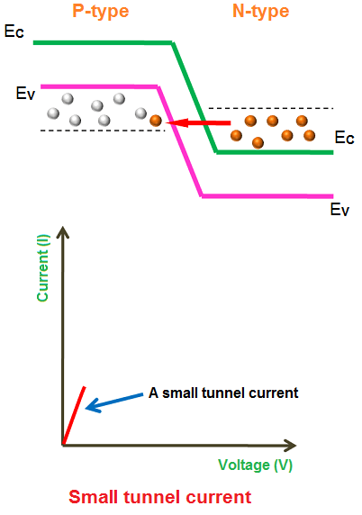
Fig. 4.4.4. Forward Biased Tunnel Diode – Applied voltage is low than built in voltage of depletion layer
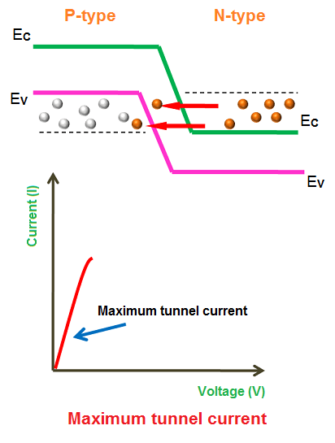
Fig. 4.4.5. Forward Biased Tunnel Diode – Applied voltage is increased to higher levels

In a biased tunnel diode – Forward Voltage is further increased
- If the applied voltage is further increased, a slight misalign of the conduction band and valence band takes place.
- Since the conduction band of the n-type material and the valence band of the p-type material sill overlap.
- The electrons tunnel from the conduction band of n-region to the valence band of p-region and cause a small current flow. Thus, the tunneling current starts decreasing.
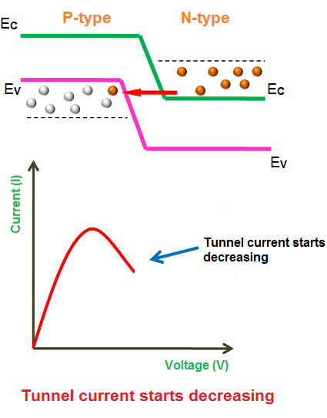
Fig. 4.4.6. Forward Biased Tunnel Diode – Applied voltage is increased to more higher levels

In a biased tunnel diode – Forward Voltage is largely increased
- If the applied voltage is largely increased, the tunneling current drops to zero.
- At this point, the conduction band and valence band no longer overlap, and the tunnel diode operates in the same manner as a normal p-n junction diode.
- If this applied voltage is greater than the built-in potential of the depletion layer, the regular forward current starts flowing through the tunnel diode.
- The portion of the curve in which current decreases as the voltage increases is the negative resistance region of the tunnel diode. The negative resistance region is the most important and most widely used characteristic of the tunnel diode.

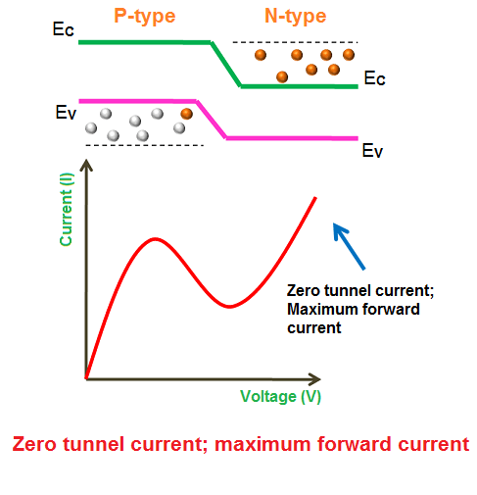
Fig. 4.4.7. Forward Biased Tunnel Diode – Applied voltage is increased to large levels

4.5. VI Characteristics of Tunnel Diodes
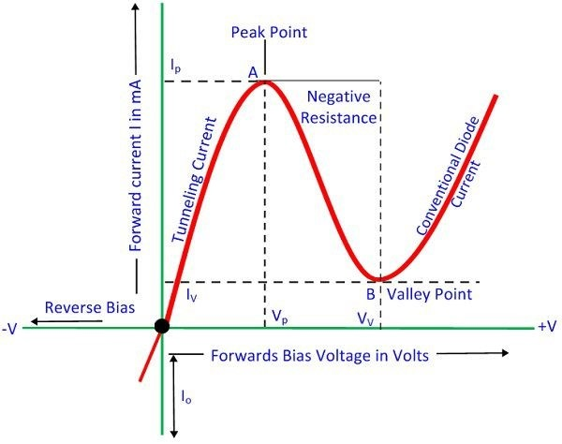
Fig. 4.5.1. VI Characteristics of Tunnel Diode
- Due to forward biasing, because of heavy doping conduction happens in the diode. The maximum current that a diode reaches is I_{p} and voltage applied is V_{p}.
- The current value decreases, when more amount of voltage is applied.
- Current keeps decreasing until it reaches a minimal value.
- The small minimal value of current is Iv. From the above graph, it is seen that from point A to B current reduces when voltage increases. That is the negative resistance region of diode. In this region, tunnel diode produces power instead of absorbing it.

4.6. Advantages & Disadvantages of Tunnel Diodes

Advantages

Long life

High-speed operation

Low noise

Low power consumption

Disadvantages
- Tunnel diodes cannot be fabricated in large numbers
- Being a two-terminal device, the input and output are not isolated from one another.

4.7. Applications of Tunnel Diodes
- Tunnel diodes are used as logic memory storage devices.
- Tunnel diodes are used in relaxation oscillator circuits.
- Tunnel diode is used as an ultra high-speed switch.
- Tunnel diodes are used in FM receivers.

4.8. Few Circuits implemented in industries

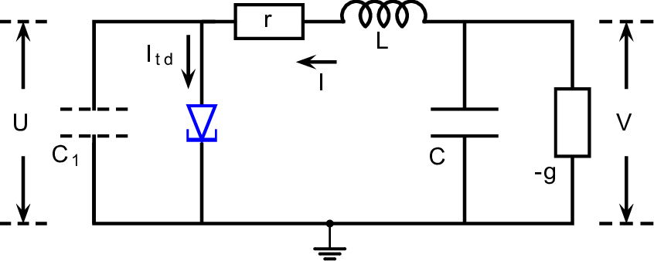

Fig. 4.8.1. Tunnel Diode in Self Sustained Oscillator

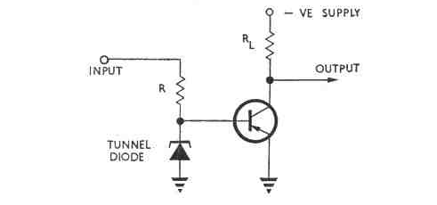
Fig. 4.8.2. Tunnel Diode -Transistor Trigger Circuit

- Liquid Crystal Displays (LCDs)
5.1. Introduction to LCDs
- An LCD is a display device that uses liquid material for its pixels.
- Like all display devices, LCDs contain many small dots, known as pixels. The pixels are illuminated by backlighting.
- When the backlighting is activated, it will project light at the pixels to create an image.
- The Liquified Crystal Display (LCD) is a flat panel display, electronic visual or video display that uses the light modulating properties of liquid crystals which do not emits the light directly.

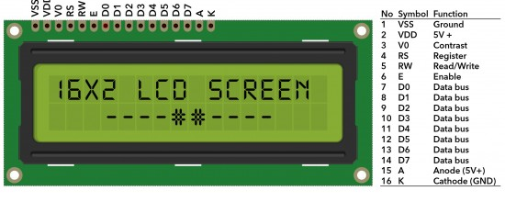
Fig. 5.1.1. Liquid Crystal Display (LCD)

5.2. Need to Study LCDs
The LCD display is commonly used in electronic digital watch displays because of its extremely low electrical power and relatively low-voltage requirements.

5.3. Constructional Details of LCDs
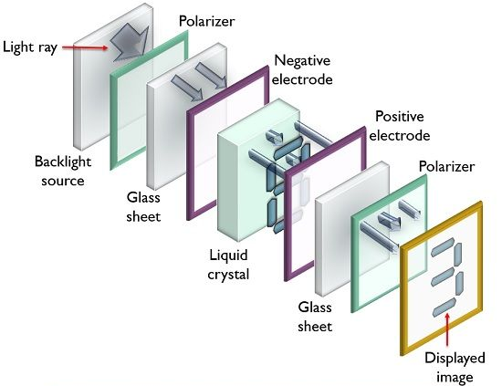
Fig. 5.3.1. Layout of Liquid Crystal Display (LCD)

What are Liquid Crystals?
- Liquid crystals are considered as the 4th state of matter. This is so because they are neither solids nor liquids. But they possess the properties of crystal and holds the ability to flow or move like liquid.
- In their crystalline structure, the molecular orientation resembles like solid. However, these molecules also show movement in various positions. Thereby holding the property of solid as well as liquid. Therefore, known as liquid crystal.
- This liquid crystal displays the images or characters as the light emitted by the source can be either passed or obstructed by the molecular movement of the crystal.
- In liquid crystal display, twisted nematic type crystal is basically used. This is so because the molecules of this nematic crystal are somewhat naturally twisted at an angle of about 90°. Also, according to the applied potential, the molecules show untwist at changing degrees.

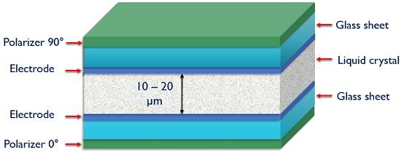

Fig. 5.3.2. Schematic of Liquid Crystal Display (LCD)

- The liquid crystal having a thickness of nearly about 10 to 20 mm is placed between two glass sheets.
- On the inner surface of the two glass sheets, conductors are inserted. These conductors form electrodes.
- The two electrodes show positive and negative polarity to be applied. The external potential is provided to the display unit with the help of these two electrodes.
- These are basically formed by materials like indium oxide (IN₂O₃) and stannic oxide (SnO₃).
- Here, a fluorescent light source is used. The light emitted by this source is then fed to the polarizer here we have considered a vertical polarizer as the input polarizer.
- Also, a polarizer of opposite polarity as that of input is placed at another end of the display unit.
- So, here if we have assumed vertical polarizer as the input polarizer then at the other end it must be a horizontal polarizer.
- At the opposite end of the electrode, a glass cover is placed at which the desired image is displayed.

5.4. Working Principle of LCDs
- When light from a backlight source is emitted and allowed to fall on the vertical polarizer. Then the unpolarized light by the source gets vertically polarized.
- When initially no external potential is provided between the two electrodes, the molecules of the liquid crystal remain twisted.
- This causes the vertically polarized light to get horizontally polarized due to the orientation of the molecules.
- As we have discussed that the orientation of the two polarizers is 90° in accordance with each other. Thus, the polarizer at the other end is a horizontal polarizer.
- Hence, when the horizontally polarized light from the output of the nematic crystal is fed to the horizontal polarizer then it passes the light thereby causing illumination of the pixel. Hence, generates a visible image on the screen.
- Suppose when a large voltage is applied between the two electrodes. Then this applied voltage causes the twisted mechanism of the molecules to get damaged causing them to operate in a straight manner.
- Due to this, the vertically polarized light while passing the nematic crystal does not change its polarization.
- This blocks the vertically polarized light to pass the horizontal polarizer thereby generating a dark pixel at the display. In this way, bright and dark images are generated.
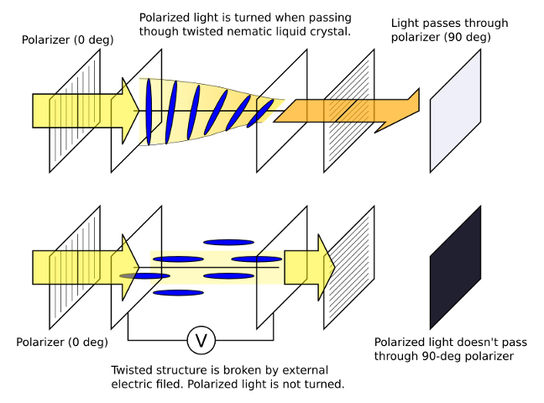
Fig. 5.4.1. Working of Liquid Crystal Display (LCD)

5.5. Advantages & Disadvantages of LCDs
Advantages:

- Slim profile
- No radiation emission from the screen
- Better under brighter conditions because of anti-glare technology
- Lighter in weight with respect to screen size
- Energy efficient because of lower power consumption
- Brightness range is too much wider produce very bright images due to high peak
intensity
- Produce lower electric, magnetic and electromagnetic fields
- Zero geometric distortion
- Excellent contrast

- Low flicker rates
- An image is perfectly sharp at the native resolution of the panel side
- Number of pixels per square inch is typically higher than any other technology or
system
- Not prone to screen burn-in
- It has not affected by an increase or decrease in air pressure

Disadvantages:

- Slightly more expensive than CRT
- Can't act as a portal to another dimension
- Suffer from a motion blur effect
- High refresh rate
- Like the backlight ages, it can change colors slightly
- The aspect ratio and resolution are fixed
- Not proficient at producing black or very dark grays colors
- Restricted viewing angles
- Slow response times

5.6. Applications of LCDs
- The liquid crystal displays (LCDs) are used in aircraft cockpit displays.
- It is used as a display screen in calculators.
- For displaying images used in digital cameras.
- The television is main applications of LCD.
- Mostly the computer monitor is made up of LCDs.
- It is used in instruments panel where all the lab instruments uses LCD screens for
display.
- The LCDs are commonly used in all the digital wrist watches for displaying time.
- The LCDs are used in mobile screens.
- It is also used in video players

5.7. Few Circuits implemented in industries
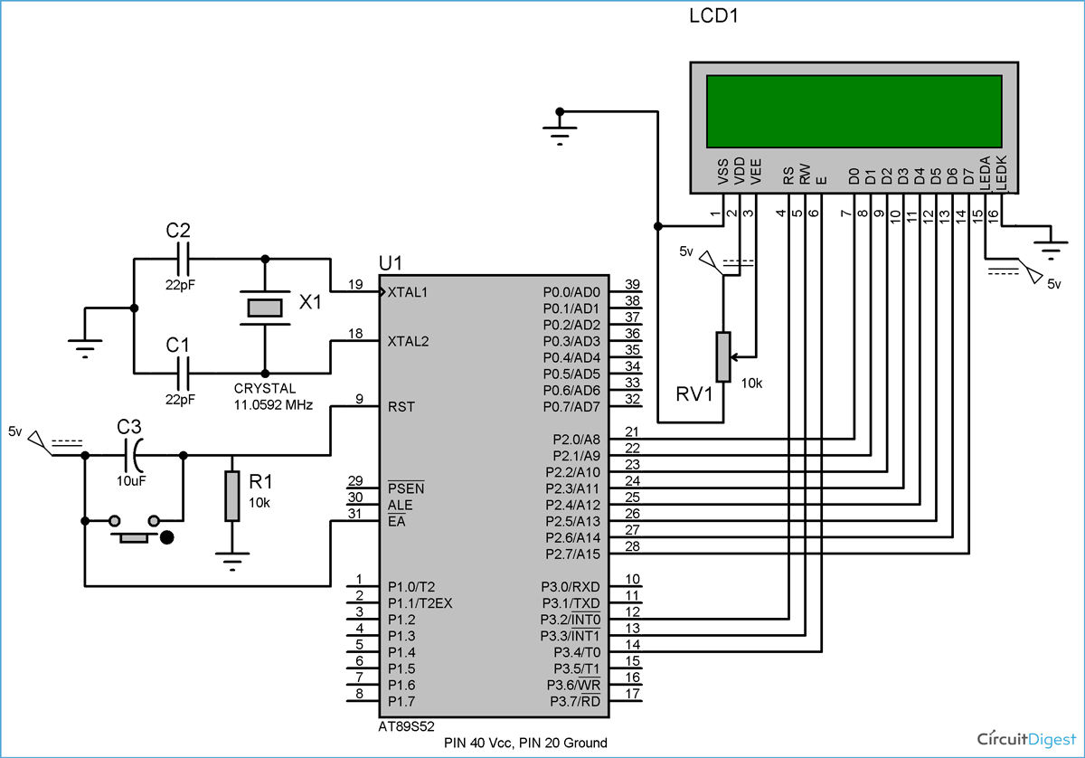
Fig. 5.7.1. Interfacing of LCD with 8051 Microcontroller

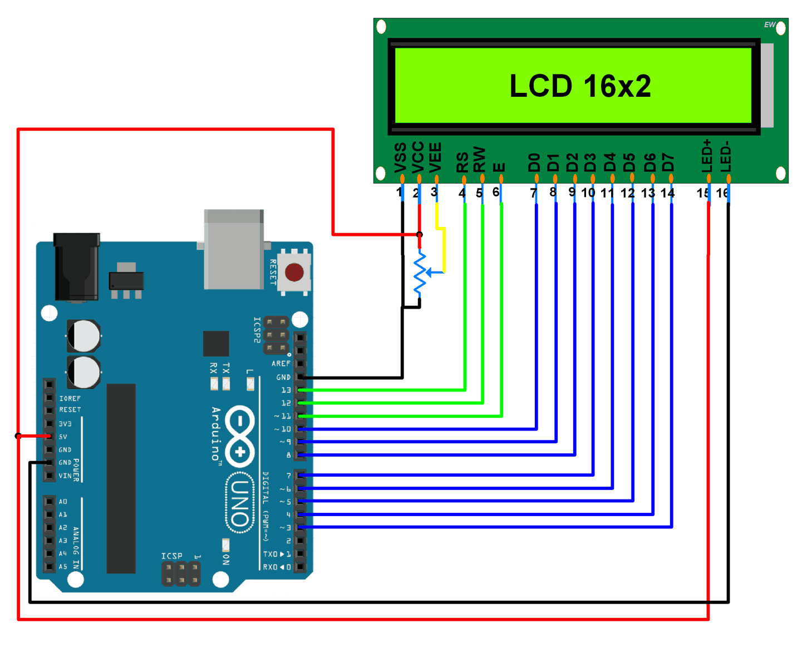

Fig. 5.7.2. Interfacing of LCD with Arduino

